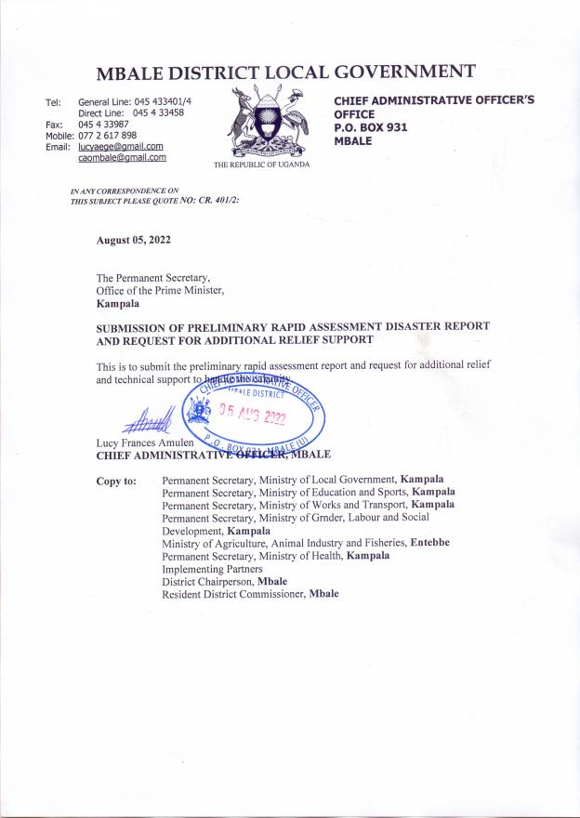
MBALE DISTRICT LOCAL GOVERNMENT
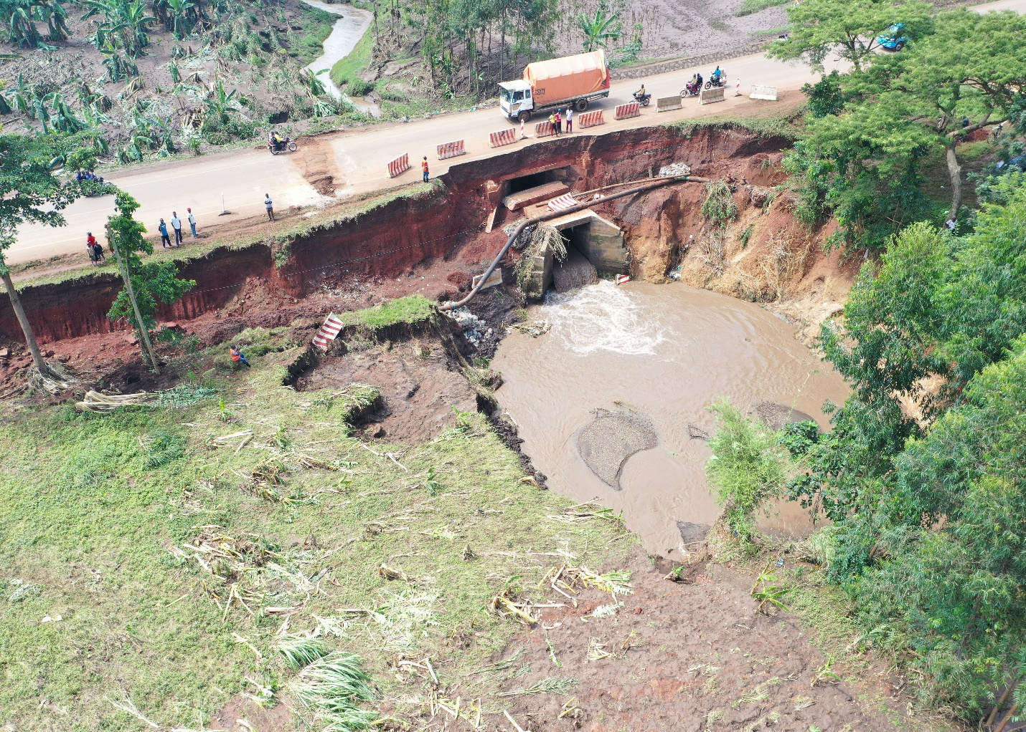
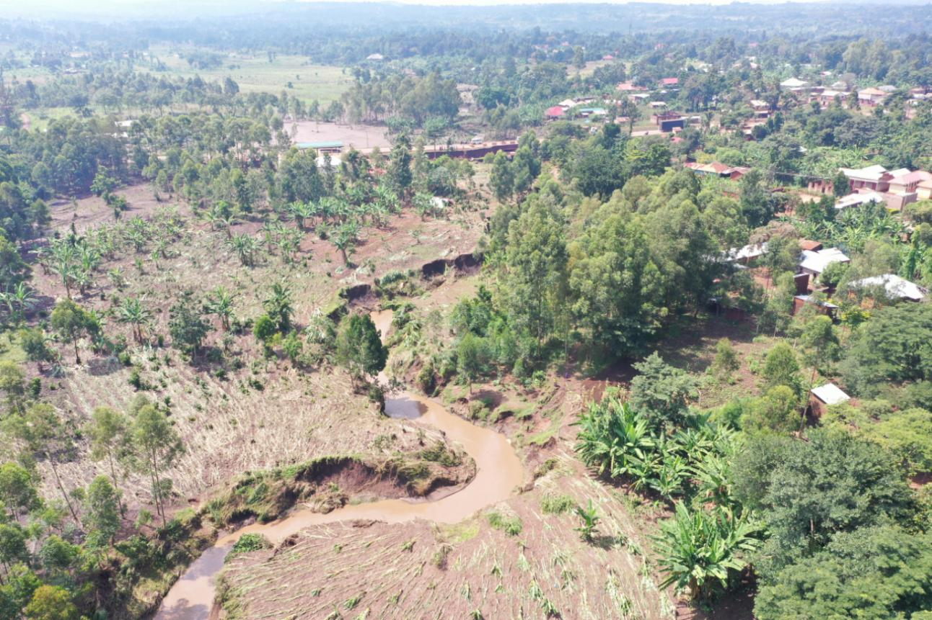
PRELIMINARY RAPID ASSESSMENT REPORT FOR THE DISASTER RESULTING FROM HEAVY DOWN POUR ON 31ST JULY 2022 FOR MBALE DLG.
AUGUST, 2022

OFFICE OF THE PRIME MINISTER AND MBALE DISTRICT DISASTER MANAGEMENT COMMITTEE

PRELIMINARY RAPID ASSESSMENT REPORT FOR THE DISASTER RESULTING FROM HEAVY DOWN POUR ON 31ST JULY 2022 FOR MBALE DLG.
1.0 Background
Elgon region is one of the regions prone to disasters associated with heavy rainfall such as landslides and floods given its geographical set up aligned in three zones. The highland zone is prone to landslides and mass wasting of soils, hailstorms, falling boulders, deep cracks, loss of lives, crops, pest and diseases, destruction of infrastructure such as gravity flow schemes and water supply pipes, property and road network cut off. The mid highland zone is also at risk and experiences the impacts of the highland disaster with falling debris and boulders destroying the houses, crops, landslides and mass wasting, hail storms, flooding, water borne diseases and infrastructure destruction while the low-lying zone experiences flooding which is wide spread, hailstorms, siltation, prolonged dry spells and associated crop and animal losses, pests and diseases, water borne diseases,
  - The situation
The early morning of 31st July 2022, we received a heavy down pour that lasted 5-6 hours across the district and a number of places, people and property have been destroyed. Several sections of the Wanale ridge experienced landslides, mass washing away of soils is wide spread and riverbanks of many rivers and streams burst causing floods and destruction of properties and crops in the lower zone /sub counties. Against this background, the District Disaster Management Committee with support from Office of the Prime Minister, Ministry of Health, Uganda Red Cross Society, Malteser International and, World Vision International conducted this rapid assessment with the purpose of establishing the extent of the damages and inform the immediate, medium and long term response by the Government and partners.

1.1.1 Rainfall data for the dates 30th – 31st July 2022

Source: Bufumbo meteorological station, Mbale District Local Government, 2022

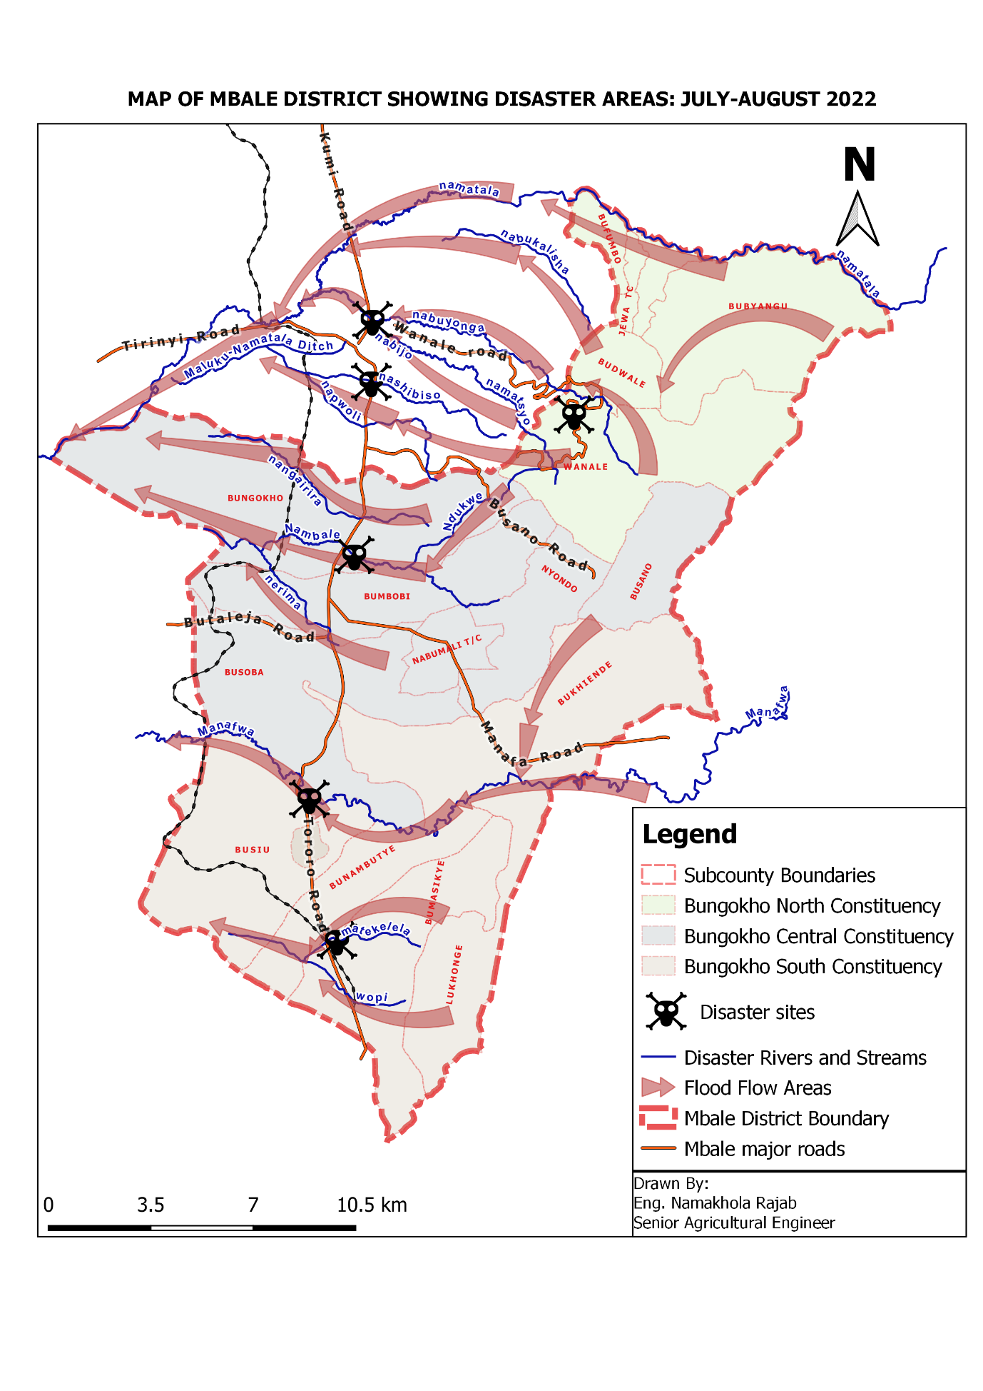
1.2 Preliminary findings
Preliminary findings indicate that landslides on Wanale ridge are wide spread, and affected several sectors including; and Transport, Housing, Agriculture, Social services, Water and Sanitation, Environment and Natural Resources on additional to general disruption of business in the affected areas. The floods also caused deaths and injuries among the community members. A summary of the findings is hereby provided in the provisional report as the assessment teams continue with the verification of the community reports.

1.3 Findings
1.3.1 Impacts on the Human Population
Description/ Category | Number | Remarks
Estimated Number of Households affected | 2,578 | The numbers seem to be raising as more houses are reportedly oozing water from underneath.
Population Affected | 18,000
Number Injured | 10 | All from Bungokho
Deaths Reported and confirmed | 04 | Bubyangu (1) Bungokho (2), Busoba (1)
Population Displaced | 1,500 | Bungokho, Busano, and Wanale
Children Displaced | 824 | Most of them from Bungokho
Source: Mbale District Disaster Management Committee assessment findings, 02/Aug/2022
Note: The summary of affected villages are provided in the appendix…….
1.3.2 Impacts on Agriculture and Livelihoods
The effects of the multi-disasters of landslides and floods on agricultural production and livelihoods, disaggregated per sub sectors are provided in the table below;

Sub sector | Acreage/ Number | Areas affected
Crops | 1,300 acres | Crops lost in Khaukha parish – Wanale, khamoto, Ndohwe, Makambo, Natondome, Lwalela Namuli, Nashe, Ndokwe, Namaloko, Bumasikye, Muruba, Shitimo Upper, Nabiri, Nabunyunga, Bunambutye, Bulusambu, Shitulwa, Bumulaha, Bubestye upper in Nyondo Sub County. Also along Wondo river in Bukhumekea and Wabukhasa, along Nambale in Mafutu Village.  Along Manafwa in Namawanga and Nambwa in Lukhonge and in Mulyuli, Magunda and Musese Koran in Bunambutye.  The crops affected include mature maize, recently planted beans, rice, onions, beans, coffee, carrots and banana.
Livestock:
Fisheries | - Fish ponds | Affected areas are in Bushikori, Nakhalapa and Bukhumwa were flooded and all fish were lost.
Poultry | Over 4500 birds lost | A poultry farm of in Manyonyi Lower, several households in Bungokho, Wanale, Budwale, Busoba, Nyondo
Piggery | 196 pigs lost | Piggery farm in bungokho, Busoba, Bunabutye, Lukhonje, Bumbobi, Bukiende
Goats | 89 goats lost | Busano, bungokho, bukiende, budwale, bumbobi
Cattle | 29 cattle lost | Wanale, Budwale, Bungokho, Bunabutye, Lukhonje, Bubyangu, Nyondo and Bufumbo,
Rabbits | 78 lost | Bungokho, Busoba, Bukiende and Busano
Napier grass | 125 acres | Wanale, Budwale, Bumbobi, Bungokho,Busoba Busano, Bumasikye, Bufumbo, Bubyangu and Nyondo
Natural grass and fodder trees | 117acres | Wanale, Budwale, Bumbobi, Bungokho, Busoba, Busano, Bumasikye, Bufumbo, Bubyangu, Nyondo s/c, Bukiende and Jewa Tc
Farm structures | 37 units flooded/ destroyed | Wanale, Bunghokho, Budwale, Bubyangu, Bufumbo, Bumbobi
sheep | 8 lost | Busano, Nyondo, Bungokho
cats | 11 Lost | Bungokho, Wanale, Nyondo, Bukiende
Dogs | 45 lost | Bungokho, Bukiende
ducks | 102 lost | Bungokho, Bukiende
Pigeons | 70 lost | Bungokho, Bukiende, Busano,
Estimated loss | 9,523,710,000 | 9,110,050,000 for crops  32,000,000 fish  381,660,000 Livestock

1.3.3 Impacts on Health Services
No health facility was directly affected by the disaster however, the health systems functionality is what may be affected in the coming weeks since the roads to some of the health centres have been cut off. Also the risk of water contamination following the destruction of the piped water network and contamination of the sources.

1.3.4 Housing infrastructure (Public and Private Buildings)
Type of damage | No of structures | Remarks
Partially destroyed | 63 | In Bubyangu, Busano, Nyondo and Bungokho S/counties
Completely destroyed | 155 | As above
Fuel station | 01 | Oil energy fuel station has been damaged with oil tanks exposed, generator damaged.
Isolation centres
Estimated loss |  | Variable/ Not yet determined

1.3.5 Water and Sanitation
Type of Source | No. | Remarks
Gravity flow schemes | 04 | Bumbobi GFS, Namukuyu, Budwale, and Wanale
Public water stands | 00 | N/A
Wells/ Springs | 03 | Bushilusa, Natondome, Makambo,
Boreholes | 02 | Manyonyi Lower
Latrines | 218 | In Bubyangu, Busano, Nyondo and Bungokho S/counties
Cost of loss from damage | 1,644,000,000 | 54,000,000 Boreholes  20,000,000 springs  480,000,000 GFS  1,090,000,000 Latrines

1.3.6 Impacts on Education Services
Description | No. | Remarks
Schools affected | 8 | Bubyangu SS, Bukhanakwa P/S, Jewa P/S, Bufoto P/S, Bushikori P/S, Bubentsye seed school, and New Hope Junior Academy in Bumageni (Private)
No. of blocks partially destroyed | 1
No. of blocks completely destroyed | 06 | Bubyangu SS, Bukhanakwa P/S, Jewa P/S - having cracked floors and compounds
Bathe shelters destroyed | 00 | N/A
Learners affected | 5,562 | For the affected areas
Teachers affected | 69 | For the above areas
Latrines | 4 in 2 schools | Bufoto P/S, Bushikori P/S, (Pit latrines sunk)
Estimated loss from damage | 592,000,000 | For both latrines (52,000,000) and Class room blocks (540,000,000)

1.3.7 Protection
Categories of Vulnerable persons | No. | Remarks
Unaccompanied Minors | 00 | No unaccompanied minors found
Child headed Households | 00 | Non
Female headed Households
Protection concerns | 56 | Total number of displaced adults in Manyonyi village
 | 15 (12 males, 3 females IDPs) | Displaced persons at Manyonyi Lower Village sharing one residence in a church of manyonyi SDA church, with men, women and the children.
 | 41 | Households staying with host families
Elderly persons | 7/56
Persons with disabilities | 1 male | Among the displaced in Manyonyi village
Protection services |  | Police stations, Probation officer at district, Community Development Officers in the sub counties

1.3.8 Impacts on the Road infrastructure
Type of road infrastructure | No. / Km | Remarks (Names of road sections, bridges)
Kilometers partially damaged |  | Mbale Nkokonjeru road is blocked by falling boulders and debris, and washed off, Buwamyange – Luwerere road, Nakhalaha - Wambewo. Bufumbo Bubyangu Road has cracked
Kilometers completely damaged |  | Busano-Bufooto road destroyed.
Bridges partially damaged | 04 | Nambale bridge on Mbale -Tororo road, Sakiya – Bukhatoko bridge  Nagairira bridge on Bumweru- Bunampongo, Passa bridge
Bridges completely damaged
Culverts partially damaged |  | Nashikhaso - Namawanga road, Ndohwe and Nambitsi, Busano road, Namashele- Sakiya , Bukatsa – Nabiri culverts, Namatsyo - Nerima, Wambewo – Manyonyi, Nakhalapa - Wambewo
Culverts completely damaged |  | None
Estimated loss from damage (KM) | 24.82
Estimated loss from damage (UGX) |  | 2,744,700,000

1.4 Pre-existing capacity
District Disaster Management Committee but needs support in disaster operations planning, capacity enhancement, Equipment, food and non-food items to be able to respond effectively.
Emergency food and non-food items (tarpaulins) support has been received from Office of the Prime Minister.
Partners are supporting the ongoing assessment and verification in the field
Uganda Red Cross is supporting the food distribution in the communities

1.5 Proposed immediate Interventions
Sector | Description of Intervention | Quantity Needed | Quantity available | Gap | Responsible Party | Timeline
Food | Supply of relief food items | 68,682kgs of Maize flour | 20,000kgs | 48,000Kg | OPM | Immediate
Food | Supply of relief food items | 34,341kgs of beans | 10,000kgs | 24,341kgs | OPM
Health | - Community sensitization | 51 |  |  | OPM, MOH, BAYLOR | Immediate
Health | - Prevention of communicable diseases |  |  |  | OPM, MOH, BAYLOR | Immediate
Health | - Radio talk shows | 60 |  |  | OPM, MOH, BAYLOR | Immediate
Health | - Capacity building among health workers, VHTs  - Fuel | 500 |  |  | OPM, MOH, BAYLOR | Immediate
Roads | - Reshaping road cambers and carriage ways  - Regraveling  - Reinstallation of culvert lines and broken culverts  - Install gambions and damaged wing walls |  |  |  | Mbale DLG, UNRA  MoW | Immediate
Shelter | - Temporary shelter  - Tarpaulins  - Non-food items |  |  |  | OPM, Redcross  Mbale DLG | Immediate
Water | - Sensitization on safe water chain, fecal matter and waste disposal  - Provision of water treatment tablets |  |  |  | Mbale DLG | Immediate
Sanitation | - Sensitization on fecal matter and waste disposal  - Provide hand washing facilities  - Provision of mobile toilets |  |  |  | Mbale DLG | Immediate
Education | - Lose the affected schools for cleanup / renovation works  - Shift learners from cracked schools  - Reconstruct damaged class room blocks |  |  |  | OPM, MOES  Mbale DLG | Immediate before third term opening
Protection, GBV and Security | - Mental health and psychosocial support  - GBV case identification and referral  - Community sensitization on referral pathways  - Radio talk shows | 6  4 |  |  | CBSD  Strong minds  KOWDO  TPO | 1st August to 31. Dec 2022
Safety of property | - Falling boulders in Jewa T/C |  |  |  | UNRA  Mbale DLG | Immediate

1.6 Recommendations on actions to take
1.6.2 Proposes Immediate response measures
- Provide alternative accommodation for the displaced households from within their own communities (Host family approach).
- Provide relief food and non-food items to all the affected households and host families such as blankets, mosquito nets, mattresses,jerrycans, plates, cups, saucepans, salt, sugar and cooking oil.
- The health response teams should be on the alert with necessary facilities, drugs and personnel.
- Prioritize provision of psycho social support to affected communities
- Prioritize rehabilitation of cut off road sections and repair the affected roads, schools, water and other infrastructure for affected people should be considered. For schools this should be immediately done before third term commences
- Provide scholastic materials and sanitary pads for the pupils and students in the affected areas
- De-silting the affected river channels should be fast tracked to prevent re-occurrence of floods
- Consider increasing the culvert sizes on the roads given that more rains have been projected for the Elgon region
- Plan for temporal placement of candidates in the affected schools to government facilities to enable them sit for their final examinations at sites such as Nyondo core PTC and Maumbe Mukhwana memorial school.
- Given that ready to harvest and harvested crops were destroyed, relief seeds should be prioritized and urgently given to the affected communities to enable them plant for the second season planting focusing on short season crops to enable farmers recover quickly.
- Reactivate and strengthen the disaster management committees at the district and Sub County levels
- Develop /Review the Emergency response plans to consider emerging issues that may have not been considered.
1.6.2 Long term interventions
- Catchment management using integrated and inclusive approaches considering livelihood support on a sustainable basis should be considered

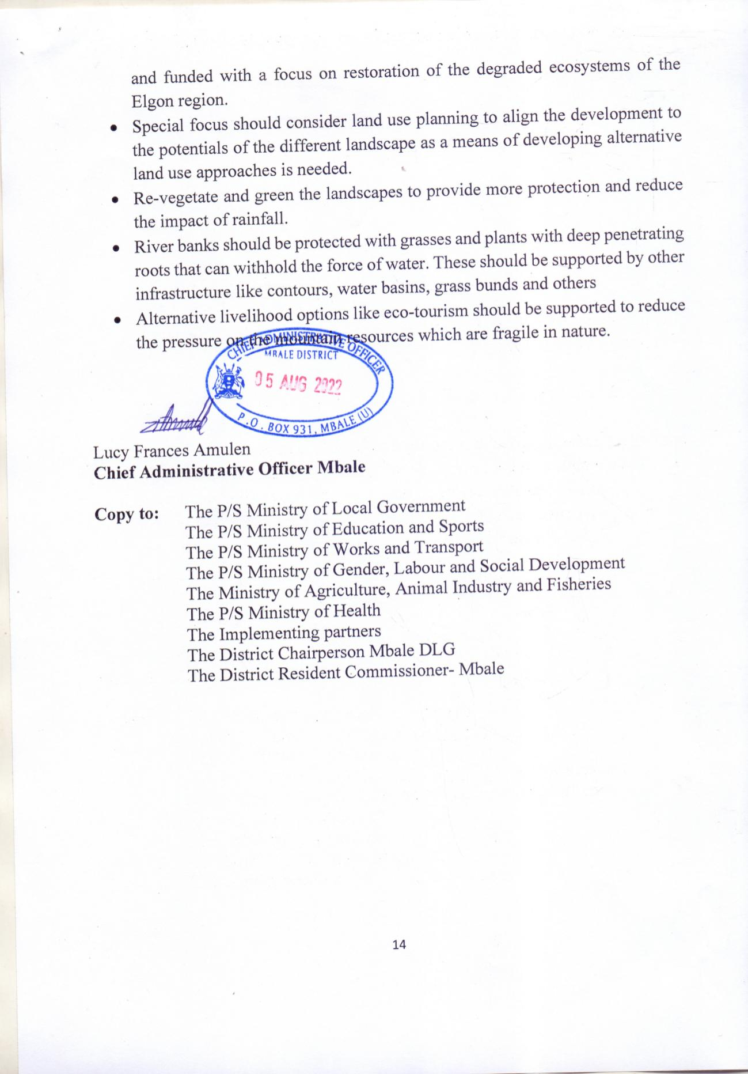

MBALE DISTRICT LOCAL GOVERNEMENT
DAMAGED ROAD INFRASTRUCTURE AFTER HEAVY RAINS OF JULY 2022
S/N | ROAD NAME | ROAD CATERGORY | LENGTH KM | DESCRIPTION OF DAMAGE | PICTURIAL VIEW OF DAMAGE | NATURE OF INTERVENTION | ESTIMATED COST OF REPAIR | REMARKS
1 | Buwalula - Namatsale | District Class 1 | 4.00 | Damaged carriage way including Broken culverts | 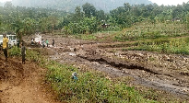 | Reinstating the road camber., Spot regravelling and reinstallation of culverts and Construction of a vented drift | 140,000,000
2 | Nasasa - Busambe | District Class 1 | 4.00 | Damaged carriage way including Broken culverts | 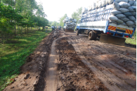 | Reinstating the road camber., Spot regravelling and reinstallation of culverts | 140,000,000
3 | Bumweru - Bukhatoko | District Class 1 | 3.00 | Damaged carriage way & washed two lines of 2.5m diameter Armco culvert | 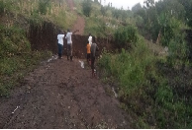 | Reshaping and spot-regravelling approximately 4km | 225,000,000
4 | Border - Bukingala | District Class III | 6.21 | Damaged carriageway and washed away broken culverts | 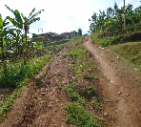 | Reshape carriageway, gravel the whole road section and install Broken Culverts | 337,350,000
5 | Namwalye - Mulatsi | District class III | 6.00 | Damaged wing wall of concrete bridge with 6m x span 10metresocncrete | 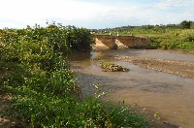 | Reshape the road section, gravel and install gabion on damaged wing wall | 210,000,000
5 | Busano - Buyango | District Class III | 5.61 | Eroded carriage way and broken culverts | 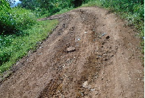 | Reshape carriageway, gravel the whole road section and install Broken Culverts | 196,350,000
6 | Busano - Buwangwa | District Class III | 6.00 | Eroded carriage way and broken culverts | 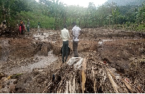 | Reshape carriageway, gravel the whole road section and install Broken Culverts | 210,000,000
7 | Sisinyo - Bukhumeka | District Class III | 4.00 | Washed away Three drainage structures | 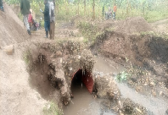 | Reshape carriageway, gravel the whole road section and constructe gabion works | 215,000,000
6 | Buwalula - Nabumali | District Class I | 5.60 | Damaged wing wall of concrete bridge with 6m x span 3m ocncrete Deck with stone masonry abutments | 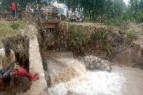 | Reshape carriageway, gravel the whole road section and constructe gabion works to the collapsed wingwall | 271,000,000
7 | Rongoro - Mulatsi | District Class I | 6.00 | 2.5m armco culvert with collapsed wingwalls | 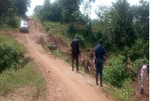 | Reshape carriageway, gravel the whole road section and constructe gabion works to the collapsed wingwall | 285,000,000
8 | Bufumbo - Namatala | District class III | 4.00 | Damaged carriage way including Broken culverts | 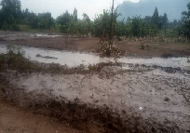 | Reinstating the road camber., Spot regravelling and reinstallation of culverts | 140,000,000
9 | Namawanga - Nashikhaso | District class III | 3.50 | Damaged carriage way including Broken culverts | 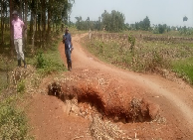 | Reinstating the road camber., Spot regravelling and reinstallation of culverts | 122,500,000
10 | Bunawunzu - Madenge | District class III | 4.00 | Damaged carriage way including Broken culverts | 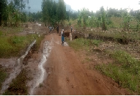 | Reinstating the road camber., Spot regravelling and reinstallation of culverts | 140,000,000
11 | Bumagira - Wampewo | District class III | 3.20 | Damaged carriage way including Broken culverts | 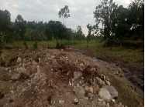 | Reinstating the road camber., Spot regravelling and reinstallation of culverts | 112,000,000
 | Total |  | 24.82 |  |  |  | 2,744,200,000

FLOOD IMPACTS IN PICTURES
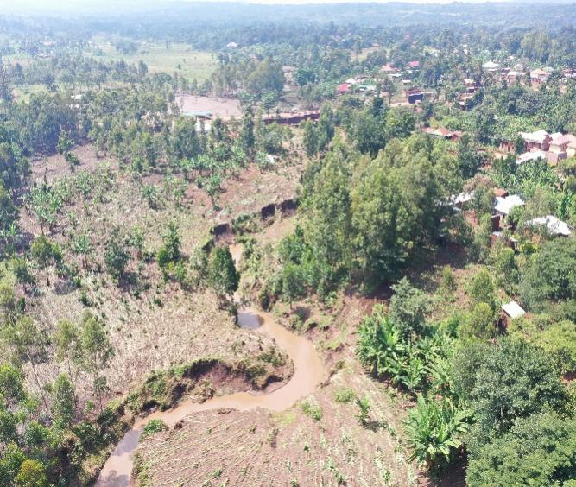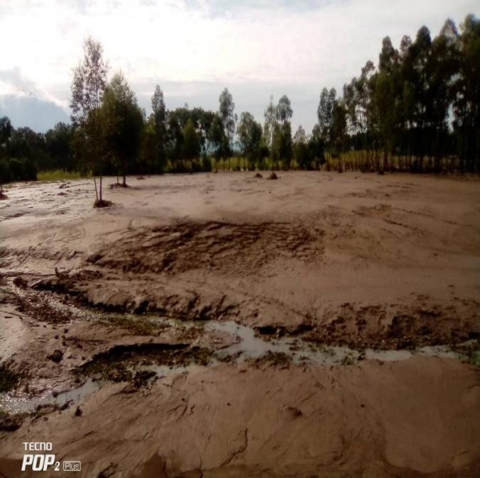
Areal view of Nambale River and the Flooded areas and silt deposited at the Mbale Tororo High way
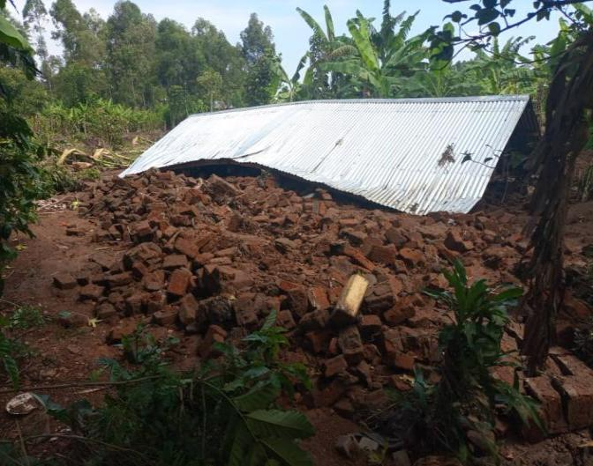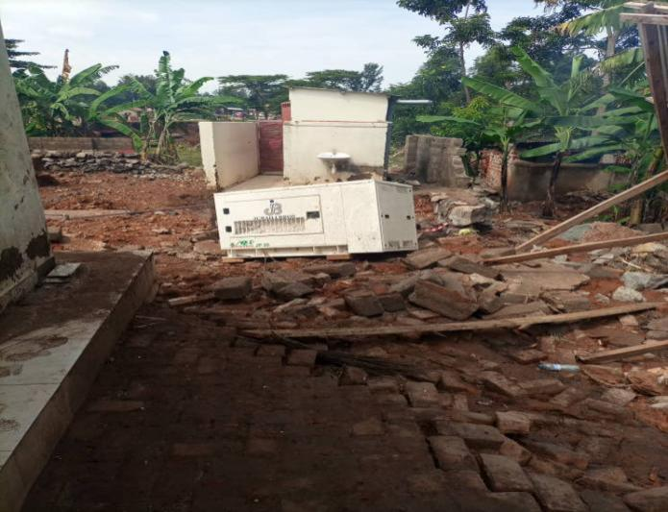
Destroyed house and fuel station at Natondome Village, Bungokho Sub county

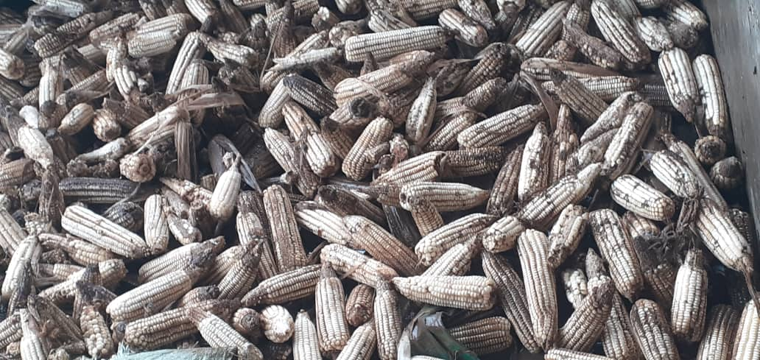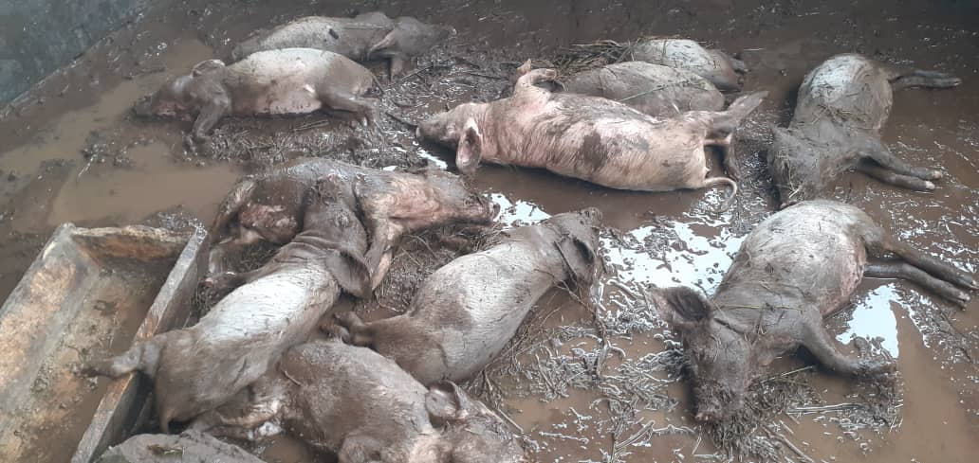
Damage at Watulatsu Sam Farm at Natondome, Bungokho Sub county
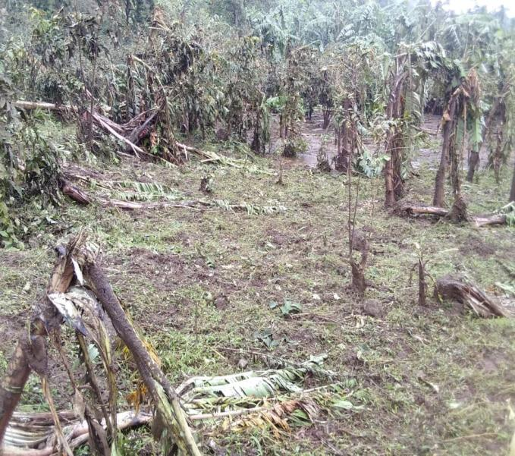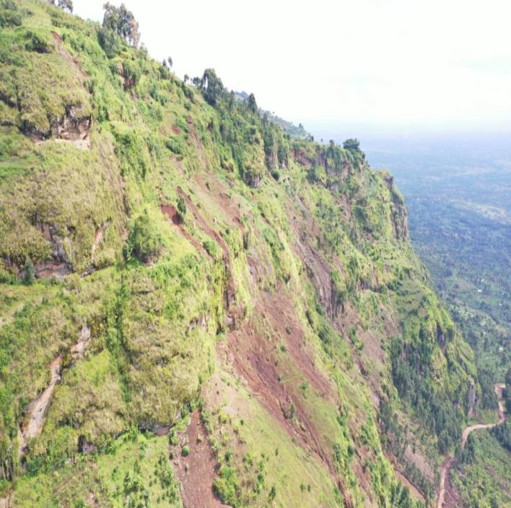
Crops destroyed belor the ridge in Bubirabi and eroded Wanale ridge
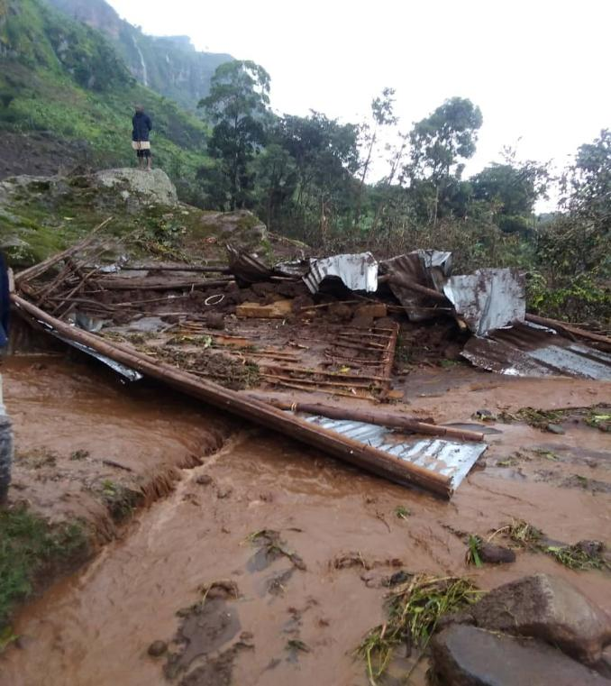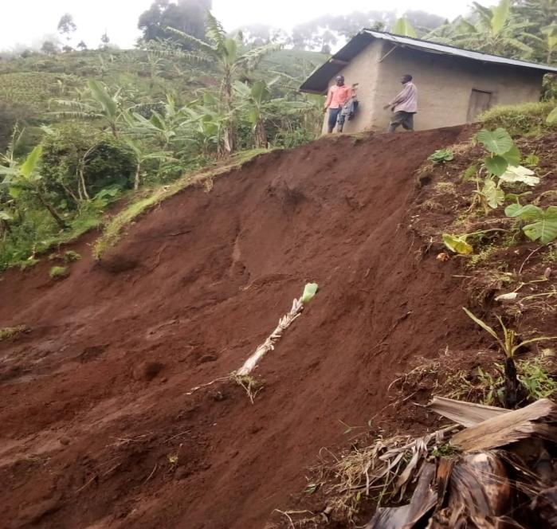
House destroyed in Bubirabi in Bungokho and Nabanyole in Wanale

